For min value

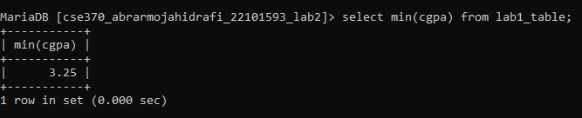

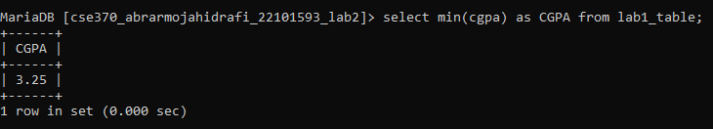

For avg

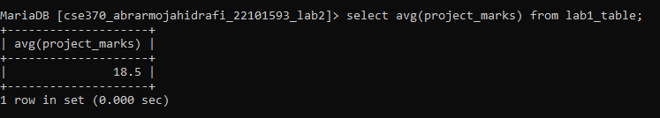

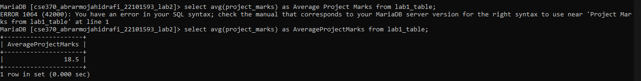

Both are Merged

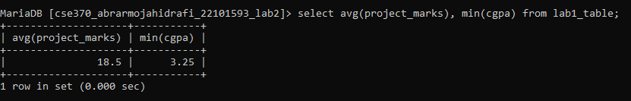

Knowing how many rows are

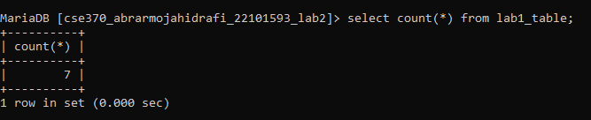

Telling the sum of a particular row

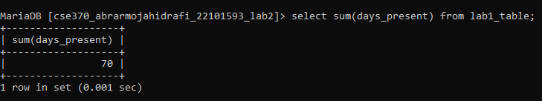

Select the last submission date

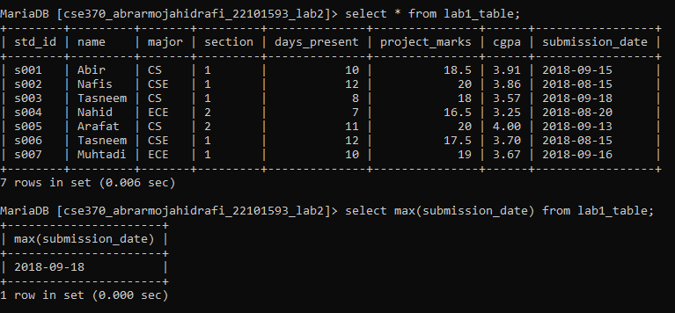

Using group by -> select max and min cgpa of each major

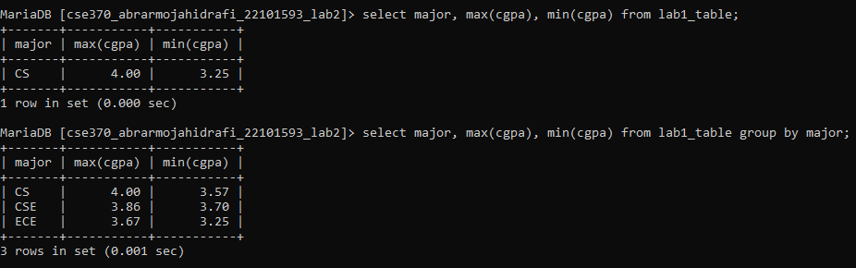

Using group by -> total number of students of each major

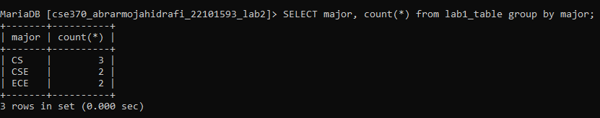

Using having

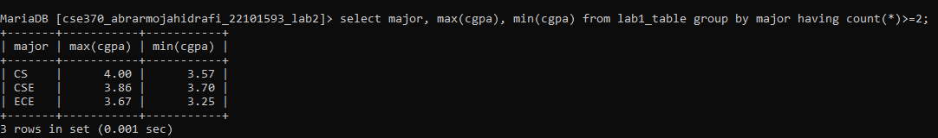

Using where

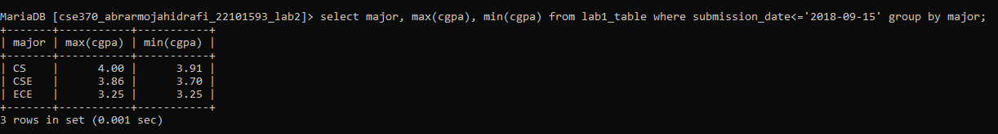

Print the name who have the highest project marks

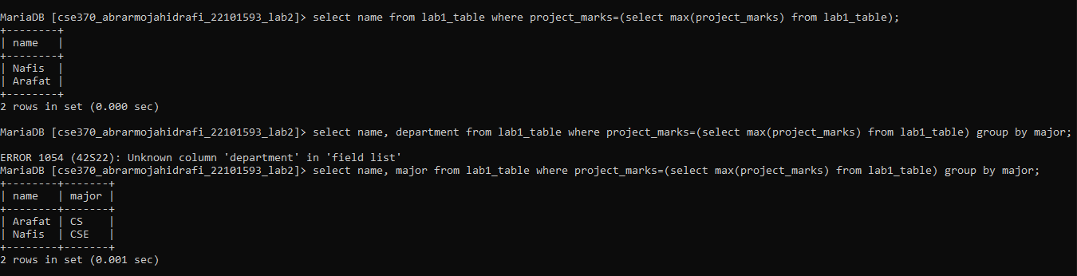

ANY-> atleast 1

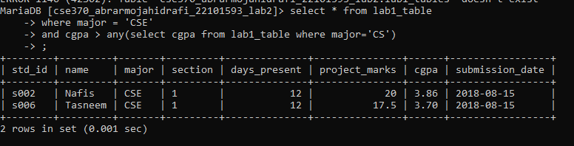

All

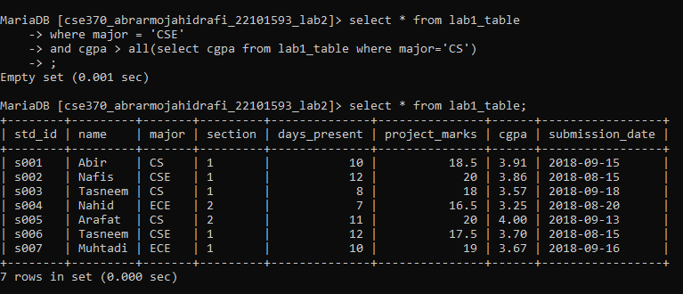

Exists

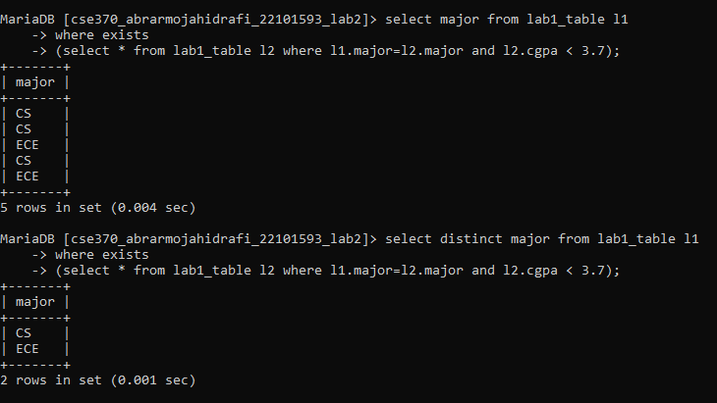

Not Exists

